What to do When LRM Freezes (or is very slow);
How to Log Off the Server
How to Purge MXD/Layer Files

How to Log off the Server:

1. Access the Connection Center
-Click on the small triangle at the bottom right of your screen (near the calendar/clock)
-right click on the Citrix app symbol
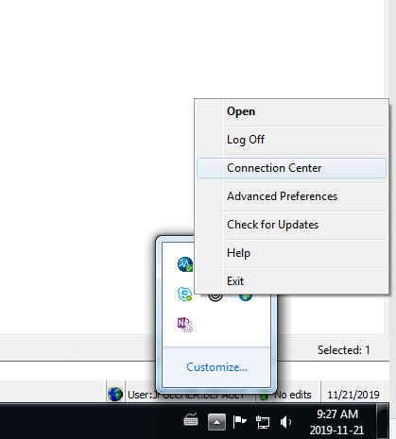
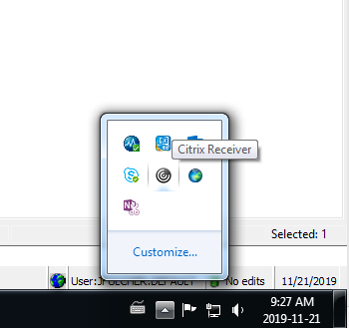
-Select ‘Connection Center’

2. Log Off your current LRM Server;
Log off from the server – Do not Disconnect from the server
*Take note of what server you are on when experiencing issues

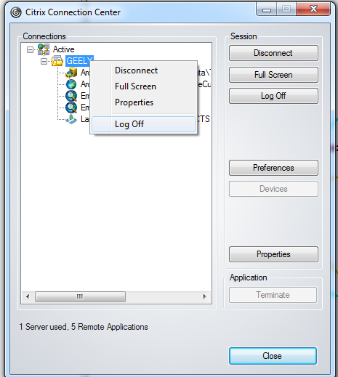

3. Sign back into LRM and check your connection center to see if you are on the same server…..if it is the same server you may want to log off and log back on again.

How to Purge MXD/Layer Files

1. Purge ArcMap Files & Layer Files
-Before launching Map View;
-Go to the File menu at the top left (in LRM);
File -> Options -> Purge Files
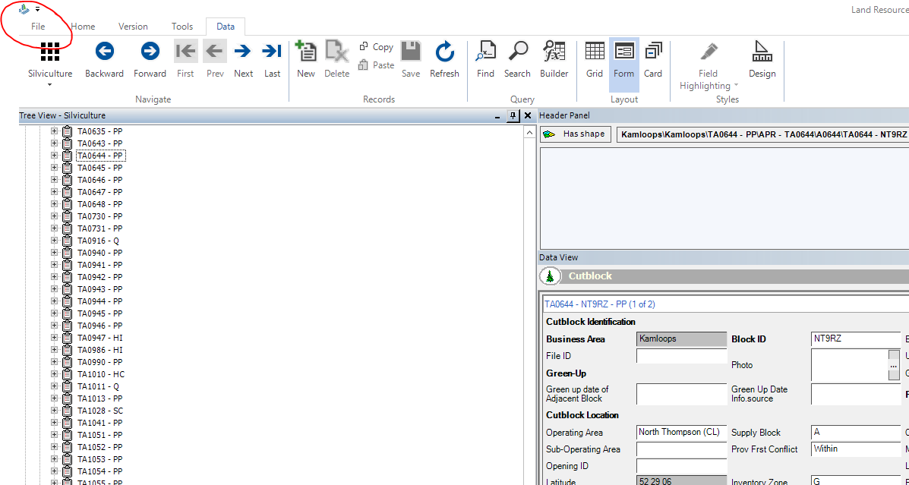

-Select ‘Options’

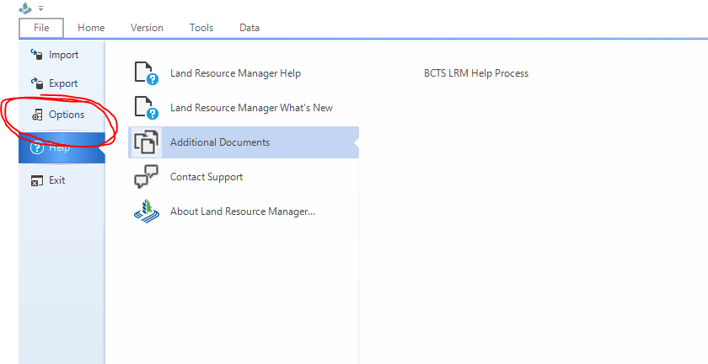

-Within the Options;
-Select ‘Purge Files’ on the left-hand side under ‘Map View’
-Click each button and select ‘Yes’ when asked “if you are sure”;
‘Purge LBESpatial.MXD File...’
‘Purge Normal.MXT File…’
‘Purge Local Files…’
*no need to purge ArcGIS Pro Files
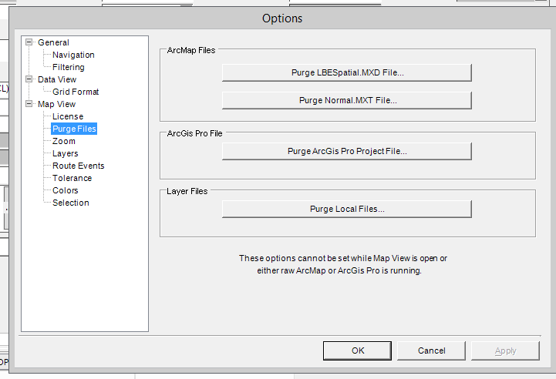

-Once you select the buttons they should grey out – indicating the process has been complete

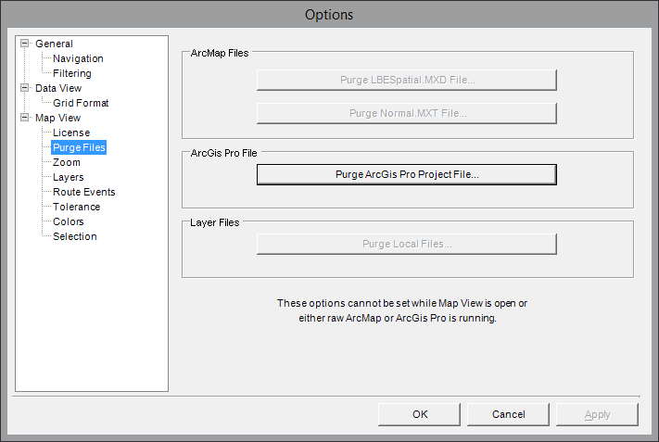
-You can now open Map view;
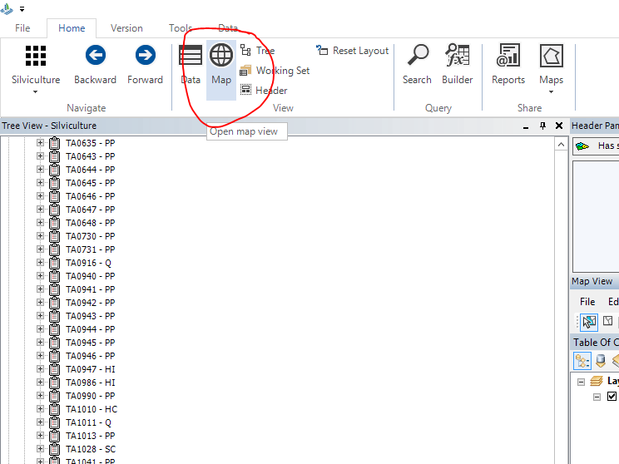

IF you get an error message like this while working in Map View;

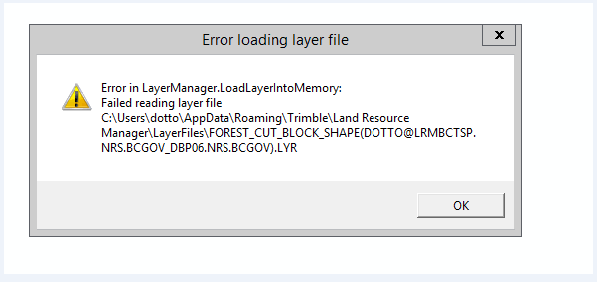

-If you can – close Map View via the File menu (top left)
*If Map View is Frozen – access your Connection Centre and Log Off the server

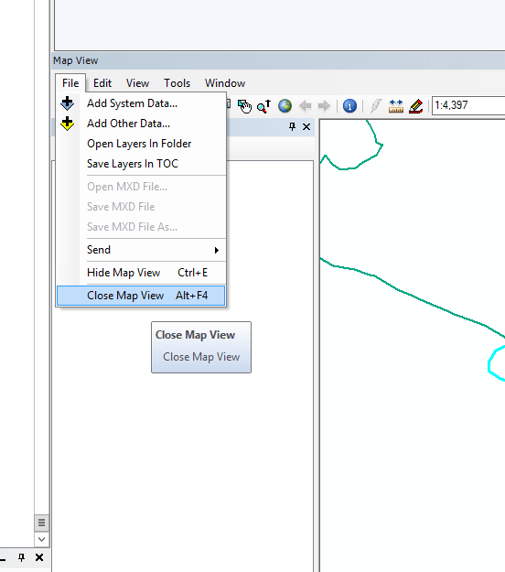

-Follow the above instructions on how to Purge MXD/Layer files
-Open Map View and try again.

